**A Report into the Peritoneal Dialysis Nursing Workforce across London**

**A Pan-LKN Report**

E**xecutive Summary**

The workforce subgroup of the LKN Home Therapies Workstream has investigated the peritoneal dialysis (PD) nursing provision across London. It has been found that there is significant variation in the numbers of nurses and the banding. The numbers of patients per PD nurse (nursing assistants and qualified nurses) varies from 10 to 22, with the largest PD unit, Barts Health, having the most patients per nurse. The skills mix also varies. St George’s does not have any non-registered (band 2-4) nursing staff whereas at Barts and Epsom and St Helier non-registered staff make up 40 and 30% of the workforce, respectively.

We sought to gain an overview of nursing roles, it was apparent that nurses take on a variety of services and roles and this varies between units. Of note, is home dialysis training, most units are using commercial providers to train the majority of their patients although many report dissatisfaction with the service.

A good quality PD service is dependent on a skilled multidisciplinary (MDT) workforce. It would be interesting to investigate how the nursing provision impacts on quality markers such as peritonitis, rates of early drop off and patient experience measures.

**Recommendations**

We encourage units to reflect on the benchmarking data included in this report and recommend that all units need:

1. Identified nursing leads who take responsibility for service delivery, governance, and quality of care.
2. Appropriately trained and resourced nursing workforce to deliver equitable access to patient-centred, in-house, home dialysis training.
3. A suitably staffed nursing workforce with an appropriate skill mix to support infection and PD access metrics.
4. Local strategies to support retention of skilled PD nursing staff and succession planning.
5. Systems to monitor staff metrics including vacancy rate and turn over.
6. To consider the use of advanced and extended nursing roles to empower the delivery of PD access and community care and support efficient patient centred pathways.

The findings of this report will feed into wider review of renal nursing workforce in London.

**Background**

There is significant variation across London in the nursing workforce in peritoneal dialysis. The roles, skills, banding and numbers of nurses differ between units. There is a lack guidance on nursing PD workforce, although the RSTP is developing an acuity-based workforce tool for home therapies.

Training people to manage their peritoneal dialysis is an important part of the nursing role. A good experience at the start of dialysis can impact on future relationships between the user and the clinical team, a meticulous PD technique is crucial to help prevent complications including peritonitis. Currently in London most people are trained by our commercial partners, overwhelmingly Baxter, with smaller numbers receiving training by Fresenius. There is variation in access to training across London which impacts on access to PD, patient experience and quality of service.

To understand the current nursing PD provision, the workforce subgroup of the LKN home therapies workstream undertook a survey of current staffing levels and roles. The LKN were given access to the results from the Association of Nephrology Nurses (ANN) PD survey. This survey was used as a starting point, nurses at units were contacted individually to verify the information. This report details the findings of the survey, discusses potential reasons for variations and makes recommendations to support an excellent PD nursing workforce and identify and tackle unwarranted variation.

**Numbers of patients receiving peritoneal dialysis in London**

The number of people receiving PD at each of the 7 London Kidney Units varies in terms of absolute numbers and as a percentage of dialysis patients. Barts Health is the largest PD unit with 237 patients (LKN data Dec 2022), Imperial and The Royal Free also have large PD programmes: 199 and 150 patients, respectively. In terms of percentage of home dialysis patients Barts Health and St George’s are the largest, nearing or above the 20% target. It is worth noting that the data only tells us about the prevalent numbers, and not the incident or turnover of patients. This is important as a high turnover will put greater demands on services; more intensive support is required when starting dialysis. Fig 1 shows the latest available data from the LKN (Dec 22) and the latest Renal Registry data (2020).

**Fig i** Numbers of people on PD at each London unit, UKRR data 2020 and LKN data December 2022

**Initial PD training**

The majority of people starting on peritoneal dialysis in London are trained by commercial providers. The exception is King’s, most of their patients are trained in house. Even units who had previously trained in house, Barts and St George’s, have moved to using commercial partners. Most units use Baxter. The nurses report inequalities in access to training, some units can book training as needed whereas others report long delays. One unit audited the time to train and found a mean time of 44 days from referral to training, another unit has been unable to book slots within a suitable timeframe with Baxter and has been using Fresenius. The nurses also have concerns regarding the flexibility of training. The rigid timeframe of the training does not suit all patients. Some people were deemed untrainable or ‘failed’ training when they just required some additional time and support for them to become competent and confident.

**Fig ii** Estimation of % of people currently trained by commercial providers

**Nursing PD Workforce**

There is a wide variation in the nursing team numbers and banding at the different units. Three of the units, Imperial, St George’s and Guy’s and St Thomas’ have combined PD and home haemodialysis (HHD) teams, they have estimated the amount of nursing time spent on PD compared with HD. Fig (iii) shows the whole time equivalent (WTE) nursing staff working in PD at each unit.

**Fig iii** PD nursing numbers and bands at each London unit

It should be noted that the six band 4 nursing assistants in the King’s team are employed to provide community assisted APD. Most other units do not provide this service in house, or as is the case with Epson and St Helier, provide a very small assisted APD service. As such a substantial number of nursing staff are working in this distinctive role at Kings, these nursing assistants have been excluded from further analysis.

In addition to variations in nursing numbers there is a variation in the nursing grades. All teams, except St George’s, have health care support worker or nursing assistant roles (band 2-4). The percentage of the total workforce which is made up of these non-registered staff is shown in table 1

|  |  |
| --- | --- |
| **Trust** | **% of nursing workforce band 3-4** |
| Royal Free | 14% |
| Epsom and St Helier | 25% |
| St George’s | 0% |
| Imperial | 7% |
| Guy’s & St Thomas’ | 11% |
| King’s | 0% |
| Barts Health | 40% |

**Table 1** Percentage of nursing workforce band 2-4;

We did not explore the roles, skills, and competencies of the different nursing grades. Staff may undertake very different roles and have varying competencies and skills depending on the unit.

Three of the teams: King’s, Imperial and The Royal Free are headed up by an 8a, at Imperial this person also manages the HHD team, she estimates half of her time is spent in PD. Other teams will be managed by a more senior nurse who is not part of the home therapies team, it is not clear how much management this person will undertake which the home therapies 8a nurse does in other teams.

The number of PD patients per nurse was calculated for each unit using the LKN December 2022 patient data. The number of patients per registered nurse (band 5 and above) and per nursing staff (all bands) was calculated.

|  |  |  |
| --- | --- | --- |
|  | **No of patients per registered nurse** | **number of patients per nursing staff (B2-8a)** |
| Royal Free | 17 | 15 |
| Epsom and St Helier | 22 | 16 |
| St George’s | 18 | 18 |
| Imperial | 19 | 18 |
| Guy’s & St Thomas’ | 12 | 10 |
| King’s | 15 | 15 |
| Barts Health | 37 | 22 |

**Table 2** Number of patients per nurse.

There is a variation in the number of patients per nurse, with the largest unit, Barts, having the most patients per nurse. Guy’s has the fewest. It should be noted that with small teams a small change in staffing or PD numbers can make a significant difference to the ratios. Guy’s saw a reduction of 28% of the number of patients on PD from 2020 to 2022, changing the ratio of patients to nursing staff from 14 to 10.

To investigate the differences further it is important to consider the roles the nurses undertake at the different units and the services they provide. Nursing should not be looked at in isolation, it is important to consider the other teams and healthcare professionals involved in the services and the roles they undertake. For example, the nurses at King’s train most of their patients and insert PD catheters, whereas these roles are often undertaken by other people in other units. The ANN survey attempted to gain more information on the nursing workload. They asked about the level of service in terms of out of hours and ward cover (see table 3)

|  |  |  |  |  |  |  |  |
| --- | --- | --- | --- | --- | --- | --- | --- |
|  | **Royal Free** | **Epsom and St Helier** | **St George's** | **Imperial** | **Guy's and St Thomas'** | **King's** | **Barts** |
| **5-day service** |  | x | x | x | x | x |  |
| **6-day service** | x |  |  |  |  |  |  |
| **7-day service** |  |  |  |  |  | aAPD | x |
| **out of hours on call clinical & technical service by PD team** |  | x |  |  |  |  |  |
| **out of hours on call clinical & technical service by ward** |  |  |  | x | x | x | x |
| **acute in-patient service by PD team** | x |  | x |  |  | x | x |
| **hybrid acute in-patient service** |  | x |  |  |  |  |  |

**Table 3** Out and hours and ward service provided by PD teams (ANN survey 2021)

Four units provide an acute inpatient service, one unit provided an on call out of hours service. Most units provide a 5-day service with the Royal Free Providing a 6-day service and Barts a 7-day service. The number of patient contacts were also investigated (see table 5)

|  |  |  |  |  |  |
| --- | --- | --- | --- | --- | --- |
|  | **Telephone** | **Routine Unit** | **Routine Home** | **Urgent Unit** | **Urgent Home** |
| Royal Free | data not provided | | | | |
| Epsom and St Helier | 10 | 15 | 3 | 2 | 1 |
| St George's | 6 to 10 | 5 to 6 | 1 to 2 | 3 to 4 | 0 |
| Imperial | 30 to 40 | 25 to 30 | 6 to 8 | 8 to 10 | 2 to 3 |
| Guy's & St Thomas' | 10 | 6 | 4 | 3 | 2 |
| King's | 15 | 6 | 12 | 2 | 1 |
| Barts Health | 6 | 5 | 3 | 3 | 1 |

**Table 5** Estimation of PD nursing team daily contacts (ANN survey 2021)

King’s and Imperial undertake more home visits that the other units, this might be reflective of the aAPD service at King’s. Imperial also sees more people at the unit and reviews more via telephone.

Discussions with the PD nursing teams have revealed a wide range of roles undertaken and services provided. Table 6, although not exhaustive, lists some of the nursing roles.

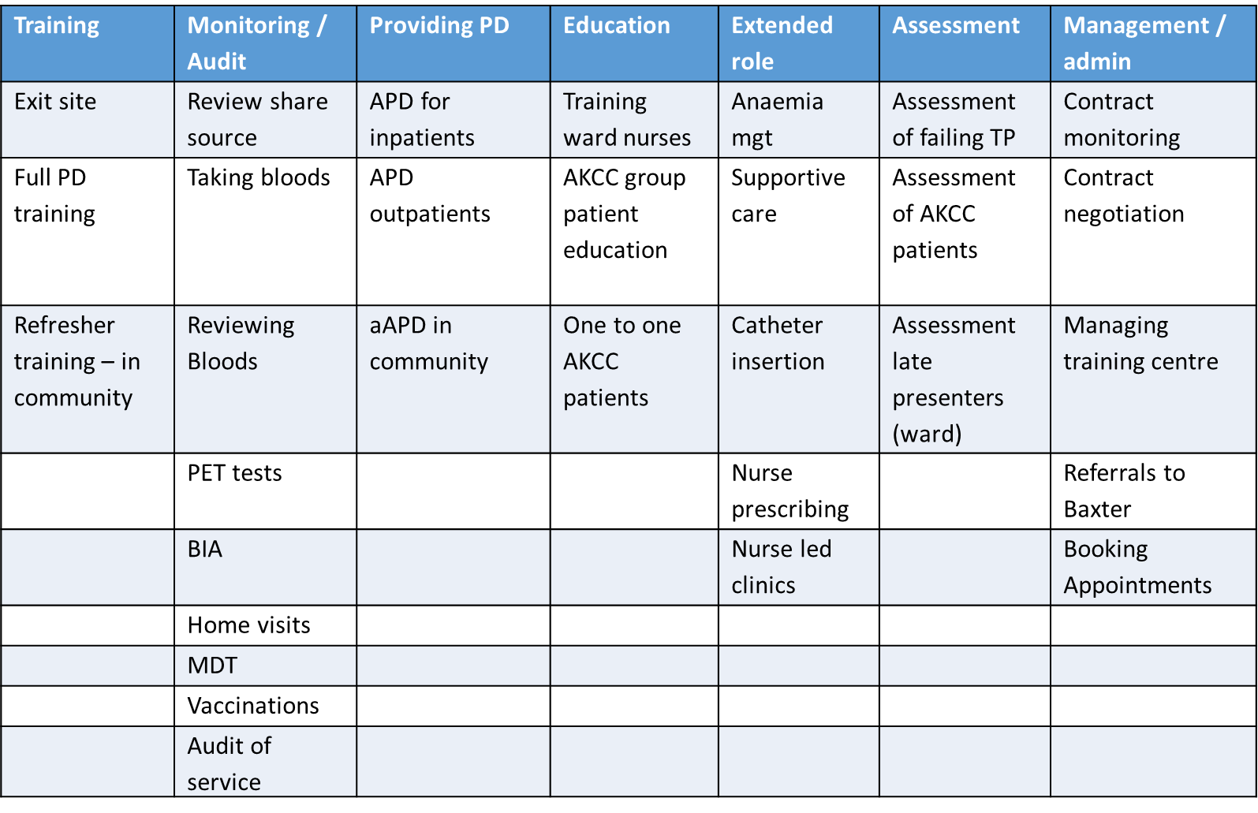

**Table 6** Nursing roles

The various roles undertaken by nurses in each unit have not been investigated and we have not explored if other teams / healthcare professionals provide these services / roles or whether the unit does not provide some of these services at all. It might be that nursing numbers limit which activities can be undertaken, and services provided.

**Limitations of survey**

We have compared prevalent numbers of PD patients with nursing workforce, the incident patient numbers and turn-over of patients may vary between units. This is important as patients typically require more support and nursing time when starting dialysis.

We have compared nursing numbers with numbers of patients on PD but have not considered any other quality markers such as peritonitis rates, early drop off rates and patient feedback.

To fully explore whether there are warranted differences in staffing numbers and whether the nursing workforce limits the roles which the nurse or the units can undertake it would be necessary to investigate the roles undertaken at each unit.

**Recommendations**

We encourage all units to reflect on the benchmarking data included in this report, to consider if local staffing levels support a good PD service and any limitations they might place on the service.

We recommend that all units need:

1. Identified nursing leads who take responsibility for service delivery, governance, and quality of care.

There should be a clear nursing lead responsible for home therapies / PD. We recommend this nurse is sufficiently senior, band 8, and is supported in championing high quality, efficient, patient centred services with oversight of all aspects of nursing care.

1. Appropriately trained and resourced nursing workforce to deliver equitable access to patient-centred, in-house, home dialysis training.

Across London and within units we have found variation in access to and quality of home dialysis training. Feedback from patients and nurses has highlighted challenges with using commercial partners in terms of variation in time to commence training, distance to travel to access the training and lack of flexibility, in particular the inability to adapt the training model for those whom the standard offer is not sufficient. We also note that communication can be challenging when the trainers are not integrated into the PD team. For this reason, we recommend that PD training is provided by nurses who are working as part of the PD team (in house) and the nursing workforce is appropriately resourced to ensure that unwarranted variation does not occur.

1. A suitably staffed nursing workforce with an appropriate skill mix to support infection and PD access metrics.

Infection and access metric are influenced by many factors, of which nursing care is one. Nurses play an important role in preventing, detecting, and managing complications. A suitably staffed nursing workforce with the right skills is part of solution to achieving good infection and access metrics. Nursing staffing levels should be monitored locally as part of quality metrics.

1. Local strategies to support retention of skilled PD nursing staff and succession planning.

PD nursing teams face several specific challenges which impact on recruitment and retention of staff. PD nursing can be a less attractive speciality financially due to fewer opportunities for weekend and night shifts. PD nursing requires specialist skills and training, with new recruits typically requiring a greater investment in training than in many other areas of renal. The impact of this on the service is heightened due the small size of the teams and is compounded where staff turn-over is also high. It is often not possible to find temporary staff with the necessary skills to fill short term vacancies, as is the case in other areas of renal. As well as the impact on patient care, it can also lead to the perception that PD services can absorb vacancies without the need for bank or agency staff and are perhaps less critical or valuable.

A local strategy which results in improved staff retention will help achieve a skilled, stable workforce. Having experienced, knowledgeable nurses will improve patient outcomes including patient safety. In addition, there will be improvements in continuity of care, which is important to service users. Investing in retention and recruitment is likely to lead to cost savings, experienced nurses are able to provide a more efficient service and costly recruitment is minimalized. A local trust strategy that supports the retention of skilled PD nursing staff can increase staff satisfaction and morale, leading to reduced staff turnover. Lastly, there will be benefits to organisational reputation. A trust that is known for supporting the development and retention of skilled PD nursing staff is more likely to attract and retain high-quality health care professionals.

1. Systems to monitor staff metrics including vacancy rate and turn over.

Unfortunately, staff metrics collected by Trusts are often not sensitive enough to allow extraction of data for small teams. Units should develop systems to monitor PD nursing team metrics, including vacancies and turn-over, this will allow identification of staffing shortages and monitoring of the effectiveness of strategies to improve retention and recruitment.

1. To consider the use of advanced and extended nursing roles to empower the delivery of PD access and community care and support efficient patient centred pathways.

With the right training, support and governance processes experienced PD nurses can undertake a range of roles which were traditionally undertaken by others. We see examples of this across London, PD nurses are running clinics, prescribing, and inserting catheters. This can lead to a more streamlined and responsive service and greater continuity of care for the patient. It can result in cost savings for the unit. It can also have the added advantage of improving nursing recruitment and retention, by promoting professional growth and job satisfaction.

The findings of this report will feed into wider review of renal nursing workforce in London.