**Training needs analysis of renal medical trainees in Young Adult care**

**Results of a pan-LKN questionnaire**

**December 2022**

|  |  |  |  |  |
| --- | --- | --- | --- | --- |
| Status | Version | Author | Date | Changes |
| Draft | v0.1 | N Cunningham | 05.12.22 | Amended follow Michelle Allan feedback |
| Draft | v0.2 | N Cunningham/M Allan | 07.12.22 | Amended following Steering Group feedback |
| Final | v1 | N Cunningham | 07.12.22 |  |

E**xecutive Summary**

The London Kidney Network’s (LKN) Young Adult (YA) Workstream was established in December 2021. It’s Steering Group agreed in April 2022 that one of its priorities was to establish the training needs of the London renal medical trainees in this field. Its rationale was that, in order to support future best practice, the emerging Consultant workforce should be appropriately equipped to meet young adults’ needs. A sub-group was established to create a questionnaire to survey current medical renal trainees, based on a questionnaire used in a research study in America. It was adapted the questionnaire to fit UK practice, and circulated using SmartSurvey.

Responses were received from 18 trainees. The results of this questionnaire suggest that the current cohort of specialist renal trainees do not feel confident to provide care to young adults with renal disease. They feel under-prepared to manage this cohort and to pass speciality exams relating to this field. They feel strongly that they would benefit from additional training and education, and their preference is for experiential learning, alongside specific topic-based training.

**Recommendations**

1. Present findings to the renal Training Programme Directors and Head of School
2. Compare results of trainee survey with results of LKN Young Adult Patient Experience Survey to see if there is cross-correlation between areas of poorer reported experience and areas of self-reported trainee lack of confidence
3. Explore current training availability, and how it is accessed
4. Based on findings of (3), consider developing a training package to include:
   1. Clinical observation
   2. Rotations into areas with transition and/or young adult services with protected access to these services
   3. Taught sessions, either stand-alone or within existent training
   4. Signposting to existing training resources
5. Work closely with PPIE Group to ensure that learning from patients is managed in a way which protects their well-being as well as providing training opportunities to the Trainees
6. Develop metrics of training success, using questions from this questionnaire where possible to allow comparison

**Background**

The London Kidney Network’s (LKN) Young Adult (YA) Workstream was established in December 2021. Its primary aim is to respond to the 2021 Renal Service Transformation Plan’s recommendation to define good care for the transition period between paediatric and adult services. This includes defining service specifications, workforce requirements, workforce education needs, and metrics to measure success. The LKN YA Steering Group agreed in April 2022 that one of its priorities was to establish the training needs of the London renal medical trainees in this field. Its rationale was that, in order to support future best practice, the emerging Consultant workforce should be appropriately equipped to meet young adults’ needs. However, it first wanted to clearly establish what current trainees already knew and understood of Young Adult care, so as to direct its efforts most effectively to developing training and education resources.

**Method**

A small sub-group was set up to lead this work. It included renal trainees, nephrology consultants, young adults affected by renal disease and a project manager. It identified a questionnaire which had been used to conduct a similar piece of work in America: a 20-item electronic survey establishing resident and fellow experiences of young adult encounters and training at a large academic medical centre.[1] The sub-group adapted the questionnaire to fit UK practice, and sought feedback from the YA Steering Group before further refining it. The questionnaire was uploaded to Smartsurvey, an online questionnaire platform. It was circulated via the Renal Operations Officer for Health Education England (London) to the pan-London cohort of 90 renal trainees in August 2022. Reminders and further requests for it to be completed were sent in September and October, with a final request sent in late November 2022.

**Results**

Responses were received from 18 renal trainees (20% of the cohort). Of those:

* 76% were in renal and GIM posts, with the others in renal only, renal and ITU or renal and academic posts
* Around half were between two and four years into their specialist training roles; five had fewer than two years’ training, and four had more than four years
* 75% of respondents were from North London training programmes
* All had had previous experience of working with young adults (aged 16-29 years old) with at least one long term health condition

Renal Young Adult Experience

* 76% had attended a transition clinic (involving young adults moving from paediatric to adult services)
* None had attended more than three times
* 60% had experience of speaking to young adults and their families about their renal care

Confidence

**Graph 1: A table to show trainee confidence in talking to a young adult and their carers about transition to adult care**

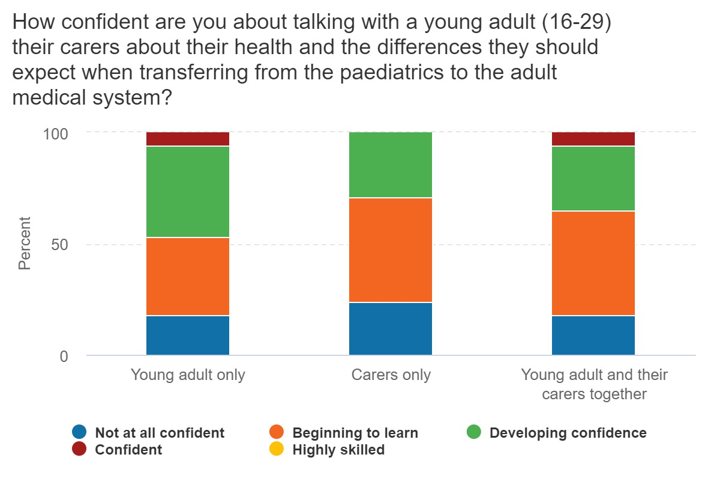

The above graph demonstrates that respondents have limited confidence speaking to young adults about the transition between paediatric and adult care, and less confidence again about speaking to young people and their carers together.

65% said they had had no previous training in this area. Of those who had, their training experience was equally divided between formal training and infrequent role-modelling.

Only two people felt confident speaking to under 18s who were newly referred with renal disease.

The graph below shows that there were varying levels of confidence when it came to speaking to those with previously diagnosed renal disease. However, around 20% still felt unconfident about speaking to those aged under 18 about any type of renal treatment.

**Graph 2: A table to show confidence in discussing renal modalities with young adults**

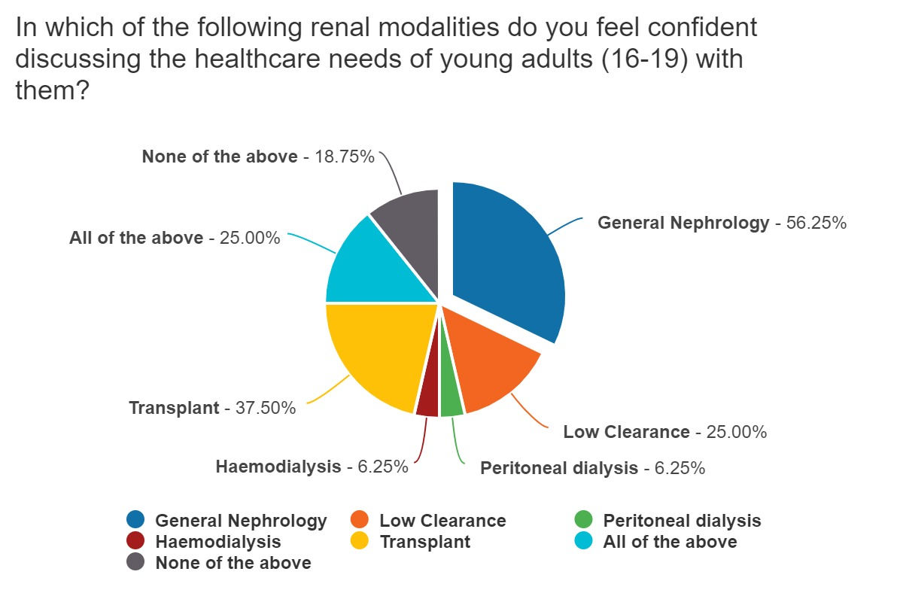

All respondents agreed it was a doctor's role to help prepare young adults to manage their ongoing health needs. However, the graph below shows than only 6% felt equipped to manage kidney disease in adolescents and young adults.

**Graph 3: A graph to show how equipped renal trainees feel about managing renal disease in young adults**

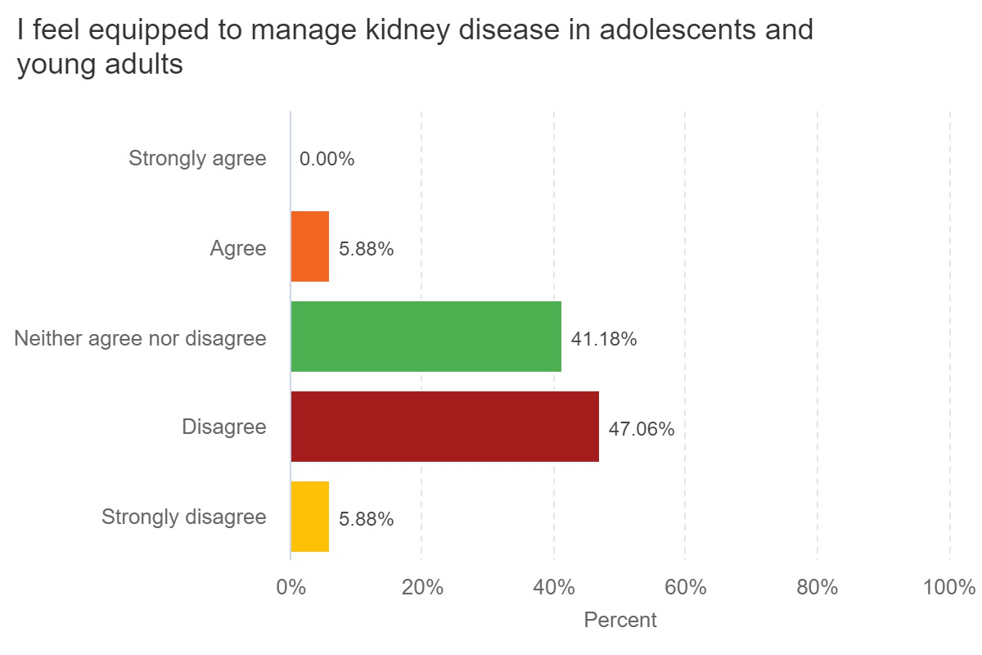

When this was broken down into specific areas of practice, the following response was seen:

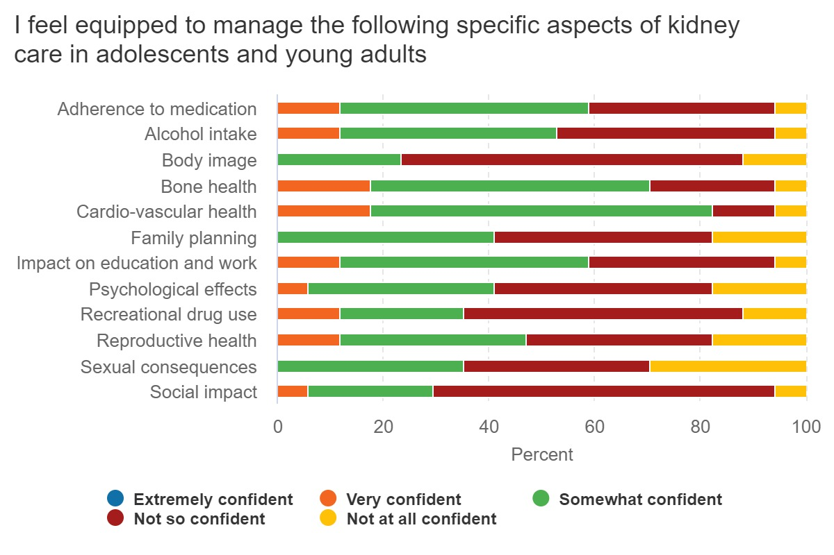

This graph shows than less than 20% of trainees felt very confident in any aspect of care. They were least confident in addressing body image, social impact, sexual consequences, recreational drug use, psychological effects, and family planning. Trainees felt most confident managing cardio-vascular health, bone health, adherence to medication, and impact on education and work.

Self-reported training needs

70% of respondents thought there was insufficient access to either training or clinical experience to enable them to pass speciality exam questions about the paediatric-adult interface. 18% thought sufficient access existed, with the remainder undecided.

Every respondent agreed or strongly agreed that they would like further training and exposure to managing young adults. The below graph shows a strong desire for experiential learning, followed by training explicitly devoted to learning about working with young adults. Only 30% thought they would be likely to engage with online learning.

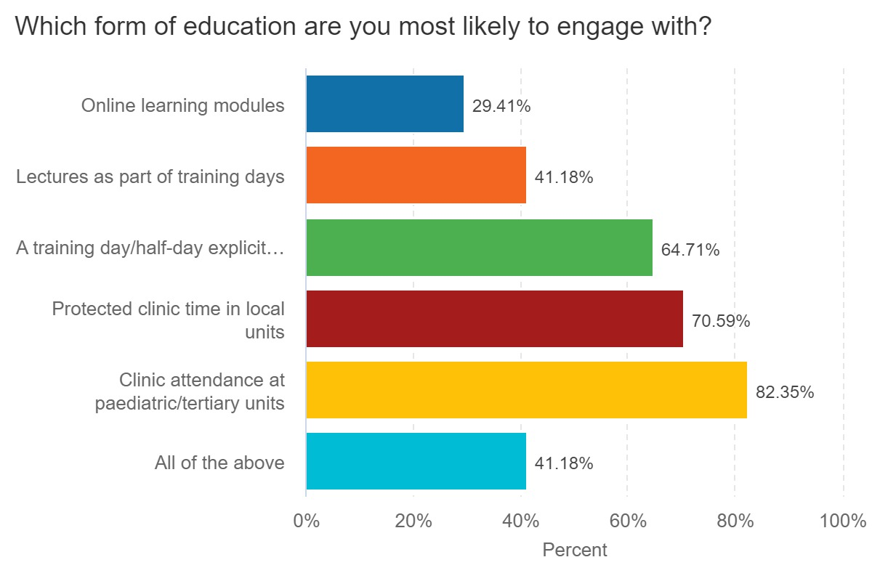

Free text responses can be summarised using a quote from one respondent:

“I think that managing young adults with advanced CKD is one of the most challenging aspects of nephrology practice. I often feel that I am not the right person to deal with the issues faced by young people.”

**Discussion**

The results of this questionnaire suggest that the current cohort of specialist renal trainees do not feel confident in providing care to young adults with renal disease. They feel under-prepared to manage this cohort and to pass speciality exams relating to this field. They feel strongly that they would benefit from additional training and education, and their preference is for experiential learning, alongside specific topic-based training.

There are some limitations to this questionnaire and so some caution needs to be taken when interpreting and applying the results.

* Of the total London cohort of 90 renal trainees, only 18 responded (20%). This may represent those who felt this was a particular issue and so took the opportunity to be heard. It could be argued that those who felt confident in the field did not see the point of answering.
* As almost 80% of respondents came from North London training programmes, it is hard to know whether these findings are applicable to the South London cohort.
* Most respondents had had between two- and four-years' experience, so it could be suggested that those with more years in post would have felt differently. While the numbers are too small to report on here, an overview of the cohort of respondents with more training does not support this argument.

**Recommendations**

1. Present findings to the renal Training Programme Directors and Head of School
2. Compare results of trainee survey with results of LKN Young Adult Patient Experience Survey to see if there is cross-correlation between areas of poorer reported experience and areas of self-reported trainee lack of confidence
3. Explore current training availability, and how it is accessed
4. Based on findings of (3), consider developing a training package to include:
   1. Clinical observation
   2. Rotations into areas with transition and/or young adult services with protected access to these services
   3. Taught sessions, either stand-alone or within existent training
   4. Signposting to existing training resources
5. Work closely with PPIE Group to ensure that learning from patients is managed in a way which protects their well-being as well as providing training opportunities to the Trainees
6. Develop metrics of training success, using questions from this questionnaire where possible to allow comparison

1. Sadun RE, Chung RJ, Pollock MD, Maslow GR. Lost in transition: resident and fellow training and experience caring for young adults with chronic conditions in a large United States' academic medical center. Med Educ Online 2019;24:1605783.